Ship2MyID Architecture Blueprint: From Scratch to Vercel Deployment

Executive Summary

This document provides a comprehensive architecture blueprint for building a Ship2MyID-like platform from scratch. It emphasizes privacy-by-design, modular interoperability, and incremental deployment while global standards evolve. The architecture is designed for Vercel deployment, leveraging modern serverless and edge computing paradigms.

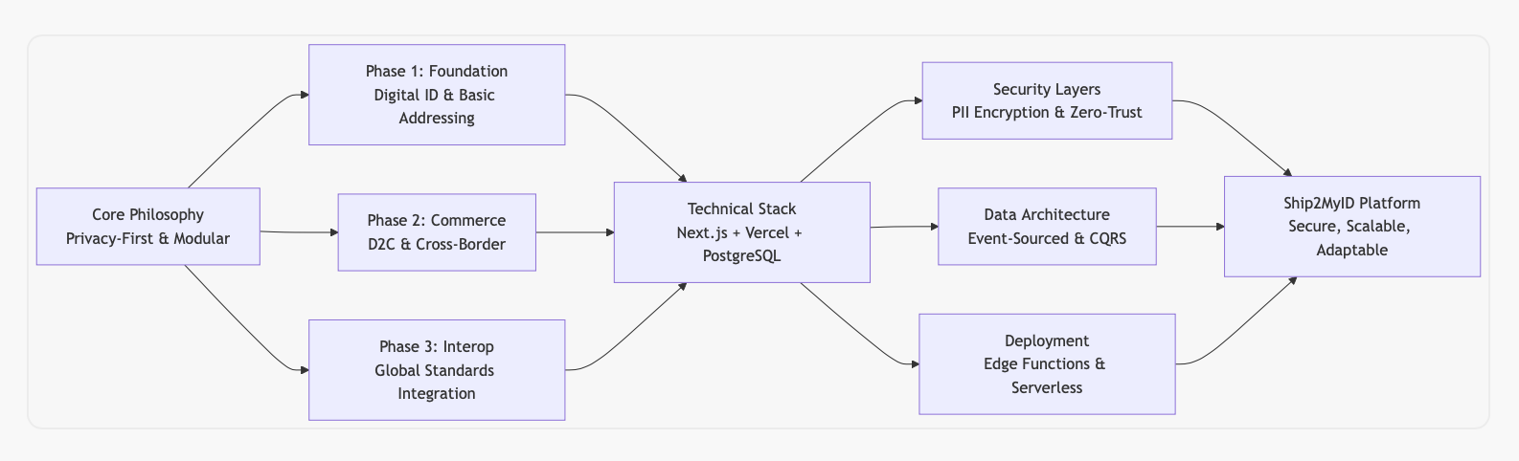

Core Architecture Principles

1. Privacy-First & Minimal PII
- Collect only what's necessary: Store demographic data instead of direct PII where possible
- Encrypt everything at rest and in transit: Use AES-256 for data at rest, TLS 1.3 for data in transit
- Implement right to be forgotten: Automated data deletion workflows with audit trails
- Zero-knowledge proofs: Where possible, verify attributes without revealing underlying data

2. Modular Interoperability
- Standards-agnostic core: Build business logic independent of specific UPU standards
- Adapter pattern for external systems: Create pluggable adapters for different national ID/Address schemes
- Event-driven architecture: Use events to communicate between modules, enabling loose coupling
- Versioned APIs: All APIs must be versioned to support backward compatibility

3. Incremental Deployment
- Feature flags: Gradually roll out functionality to different user segments
- Phased rollout: Deploy to one postal operator at a time, learning and adapting
- Shadow mode: Run new systems in parallel with existing ones before cutover
- Kill switches: Ability to instantly disable any feature or integration

Technical Stack & Skills Required

Core Technologies
COMPONENT | TECHNOLOGY | RATIONALE
Frontend | Next.js 14+ (App Router) | Server components, edge runtime, Vercel optimization
Backend | Next.js API Routes + Serverless Functions | Unified codebase, automatic scaling, pay-per-execution
Database | PostgreSQL (via Vercel Postgres) + Redis | Relational integrity + caching layer
Authentication | NextAuth.js + Custom JWT | Multi-tenant auth with postal operator separation
Encryption | Tink (Google's cryptographic library) | Proven, audited, multi-language support
Event Streaming | Vercel Edge Config + Redis Pub/Sub | Lightweight, real-time event distribution
Monitoring | Vercel Analytics + Sentry | Performance monitoring + error tracking

PII Secure Architecture

Data Classification & Handling

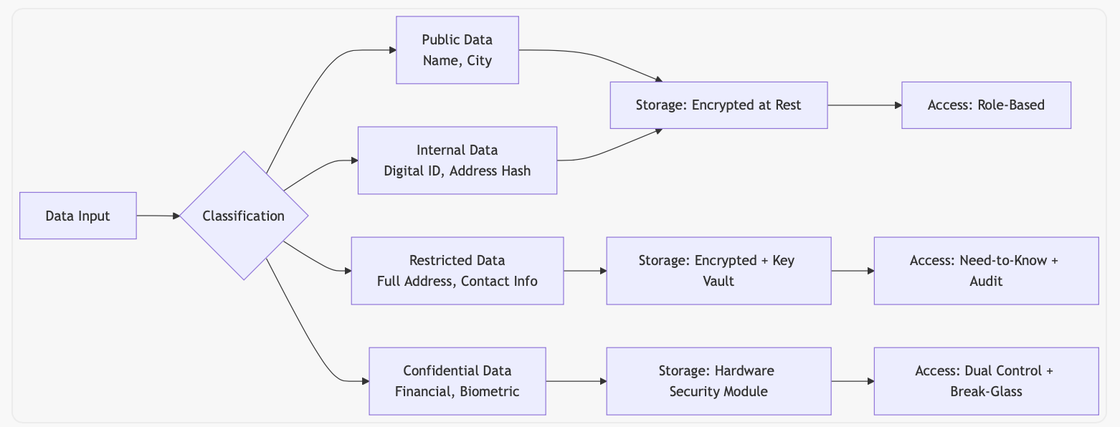

Cryptographic Architecture

Detailed Encryption Strategy

Key Hierarchy

- Master Key (HSM-protected)
  - Stored in AWS CloudHSM or equivalent
  - Never leaves the HSM boundary
- Data Encryption Keys (DEKs)
  - Generated per tenant (postal operator)
  - Encrypted with master key (KEK - Key Encryption Key)
  - Rotated every 90 days
- Field-Level Encryption Keys
  - For particularly sensitive fields (full address, financial)
  - Unique per record, derived from DEK

Encryption Implementation

// Example: Encrypting PII before storage
import { aead } from '@tinkcc/aead';
import { subtle } from 'crypto';

// Generate data encryption key
const dek = await subtle.generateKey(
{ name: 'AES-GCM', length: 256 },
true,
['encrypt', 'decrypt']
);

// Encrypt sensitive field
async function encryptPII(plaintext: string, dek: CryptoKey): Promise<string> {
const iv = crypto.getRandomValues(new Uint8Array(12));
const encrypted = await aead.encrypt({
key: dek,
plaintext: new TextEncoder().encode(plaintext),
associatedData: iv,
}, iv);

return JSON.stringify({
iv: Buffer.from(iv).toString('base64'),
ciphertext: Buffer.from(encrypted).toString('base64'),
});
}

// Decrypt with audit logging
async function decryptPII(
encryptedData: string,
dek: CryptoKey,
context: { userId: string; purpose: string }
): Promise<string> {
// Audit log before decryption
await auditLog({
action: 'PII_DECRYPTION',
userId: context.userId,
purpose: context.purpose,
timestamp: new Date(),
});

const { iv, ciphertext } = JSON.parse(encryptedData);
const decrypted = await aead.decrypt({
key: dek,
ciphertext: Buffer.from(ciphertext, 'base64'),
associatedData: Buffer.from(iv, 'base64'),
}, Buffer.from(iv, 'base64'));

return new TextDecoder().decode(decrypted);
}

Key Rotation Strategy
- Automated rotation: Every 90 days for DEKs
- Zero-downtime rotation: New keys encrypted with old keys before transition
- Emergency rotation: In case of suspected compromise

Data Access Patterns
USER TYPE | ACCESS LEVEL | DATA VISIBLE | AUDIT FREQUENCY
Consumer | Own data only | Full view of own PII | Every access
Postal Operator | Tenant data | Aggregated, anonymized | Real-time
Brand/Merchant | Verified consumers | Limited PII (demographic) | Every transaction
System Admin | Break-glass | Full access with dual control | Continuous monitoring

